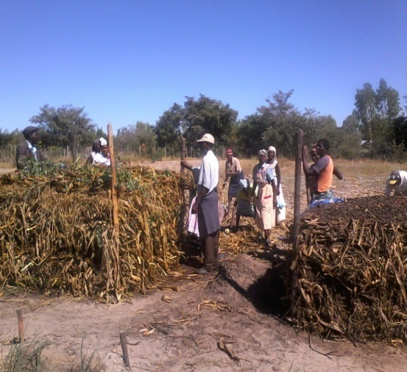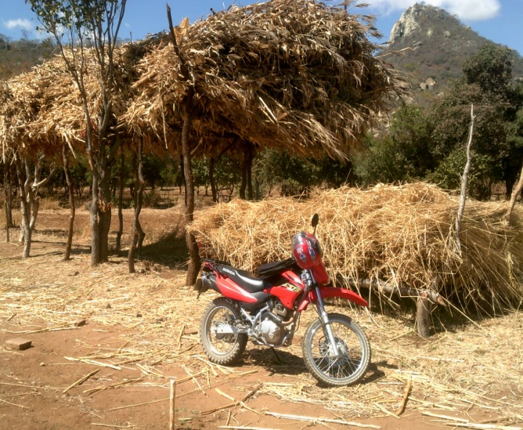
CONSERVATION AGRICULTURE TRAINING NMANNUAL
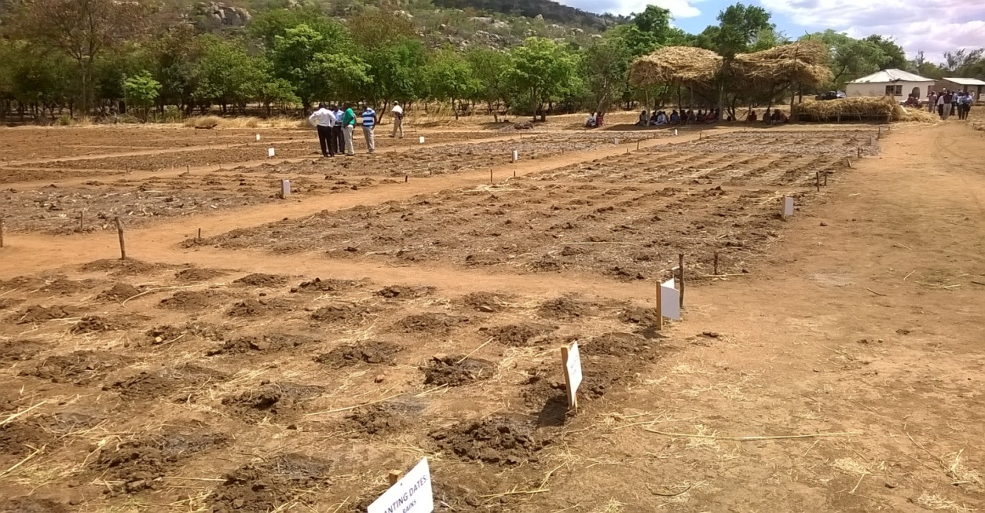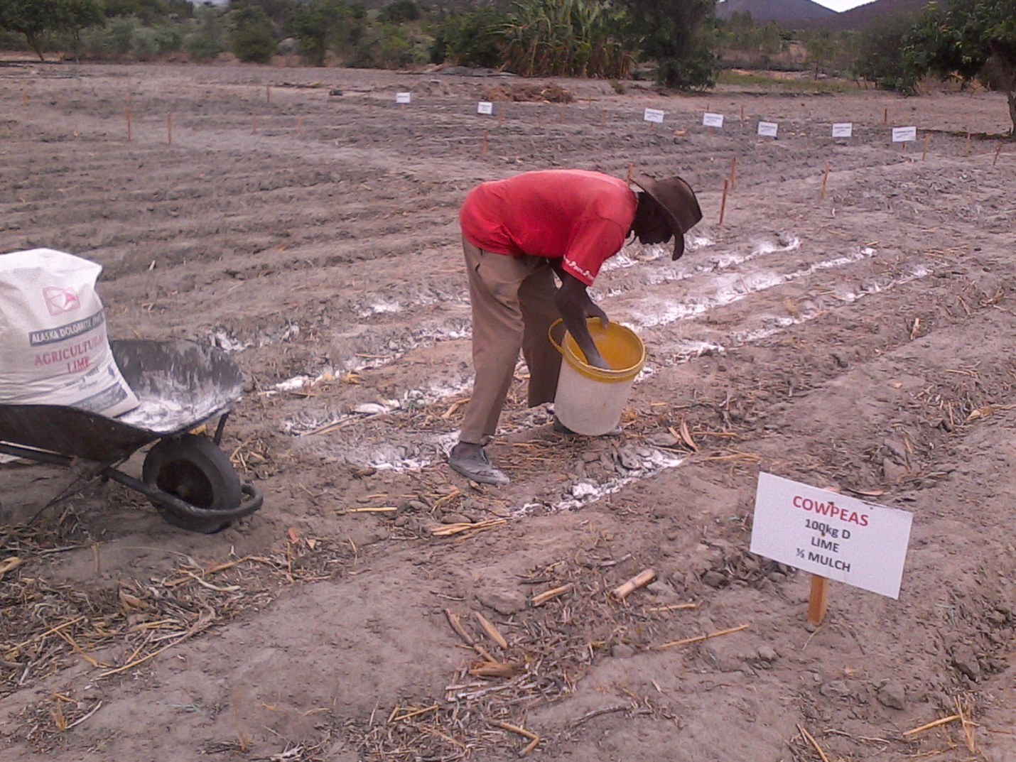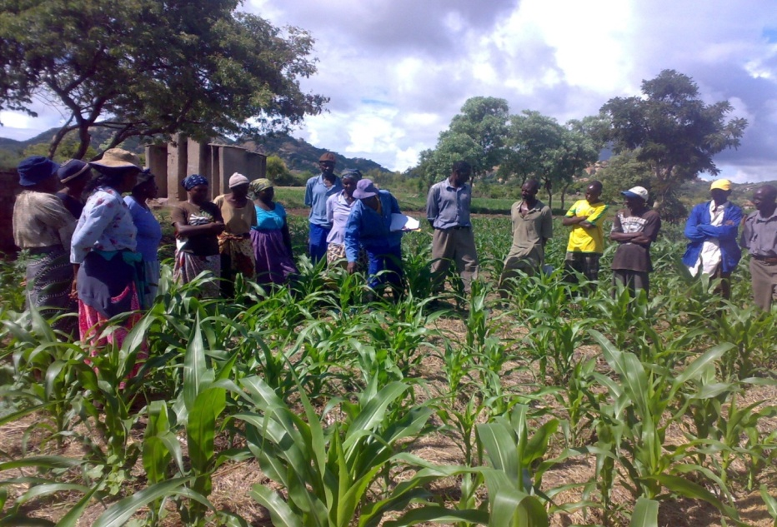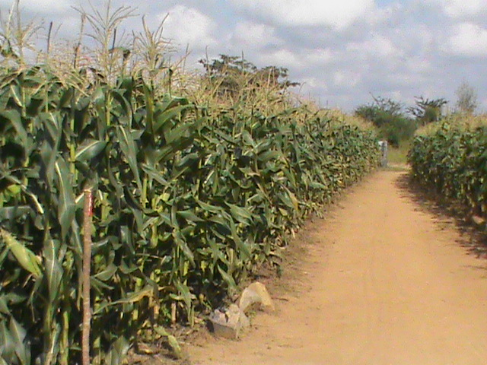
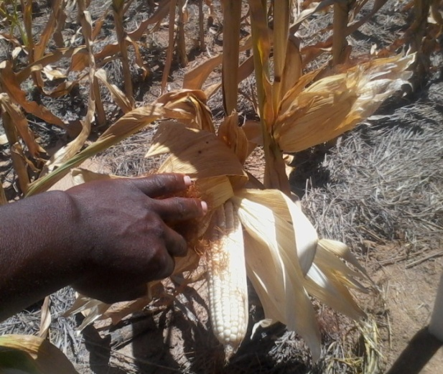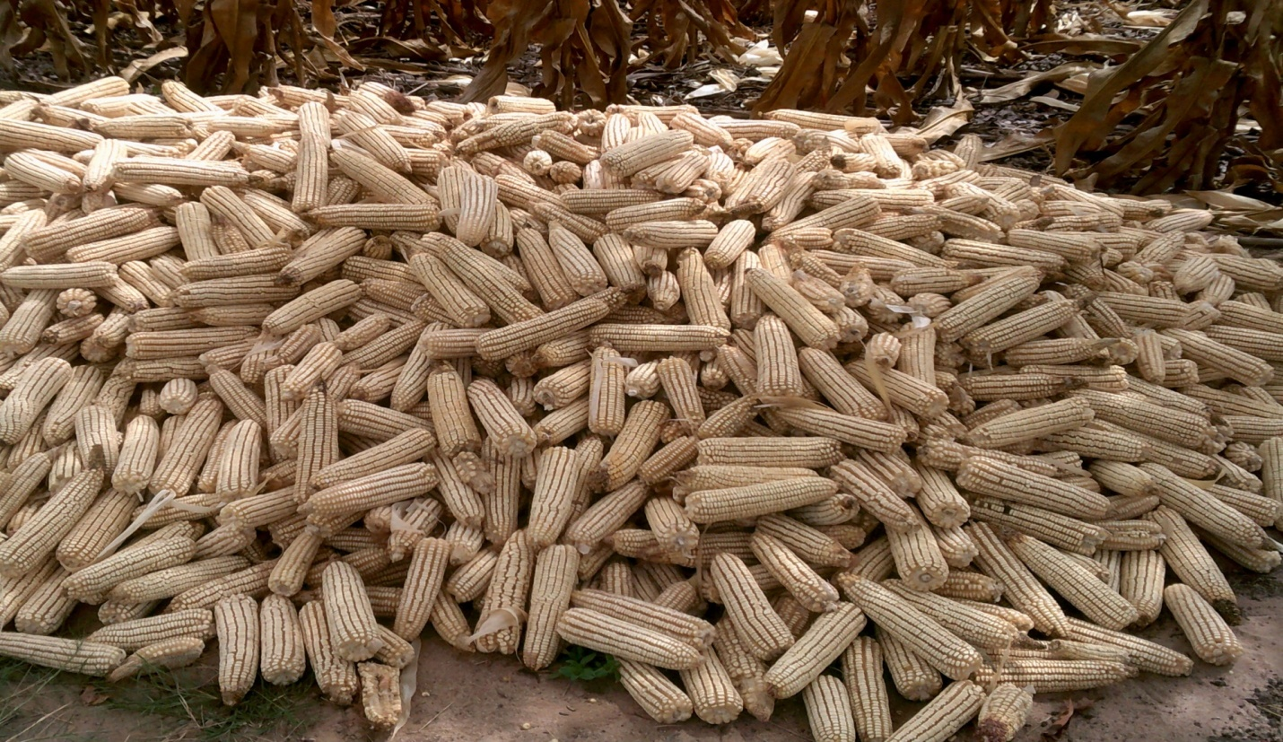

Foreword
The information contained in this training manual was gathered from farmers in Mutoko, Mudzi and Goromonzi districts of Mashonaland East Province and farmers who work with Help Germany in Gweru and Shurugwi districts of the Midlands Province. The contents elaborate on the principles of Conservation Agriculture(CA) that can be used for compost making, land preparation, basal manure and fertiliser application, planting, weeding, thinning, pest and disease control and management, pre-harvest management, sustainable harvesting and post harvest management. We thank the farmers of Gweru, Shurugwi, Mutoko, Mudzi and Goromonzi districts who agreed to contribute and participate towards the success of this training manual.
We thank Leonard Kuwona, Allen Chaitezvi, Nhamo Dapi, Angela Kafudza, Shamiso Mugwara, Lillian Machivenyika and field staff who have worked with the farmers facilitating and equipping farmers on conservation farming.
We thank the Help Germany-staff in the field, project managers, Ms Widi Hadiati, Mr .Olaf Read, Mr Jeremy Ford, Mr Steve Riley and Mr Chris Laufens.

Contents
Foreword 2
Introduction 4
Operational factors 6
Disadvantages of ploughing 7
Compaction 11
Pests 11
Diseases 12
Crop stand 12
Weeds 13
Land preparation 14
Basal dressing 15
Planting 16
Top dressing 17
Chicken manure soup 18
Harvesting 21

Introduction

What is Conservation Agriculture (CA)?

• Conservation Agriculture is a way of farming that conserves, improves, and ensures efficient use of natural resources.
• It aims to help farmers achieve profits with sustained production levels while conserving the environment.

Why Conservation Agriculture?

• Because traditional methods of farming cannot cope with the increasing needs of the ever
expanding human and livestock populations.
• Conservation actions stop and reverse land degradation.
• Conservation agriculture boosts productivity and contributes to reducing land degradation and increase food security

Principle of Minimum Soil Disturbance
- Only disturb the soil where the seed, fertilizer and manure are to be placed.
• Reduces destruction of the soil structure;
• Does not expose soil to wind and water erosion;
• Improves water infiltration rates;
• Slows the rate at which organic matter is mineralized and oxidized, so organic matter
Build-up occurs;
• Causes little disruption to the organisms that live in the soil.
• Saves time, energy, and money because less land is tilled.
• Reduces soil compaction because the crop plant roots are left undisturbed

The Principle of Permanent Soil Cover
• Helps reduce direct raindrop impact and so reduces soil erosion;
• Helps reduce runoff and helps water to seep into the soil;
• Reduces evaporation and so conserves moisture for the crop;
• Suppresses weeds emergence;
• The organic residues improve organic matter content and soil nutrient status;
• Provides a beneficial environment for soil organisms, such as worms and millipedes, that are important for biological tillage;
• Moderates soil temperatures

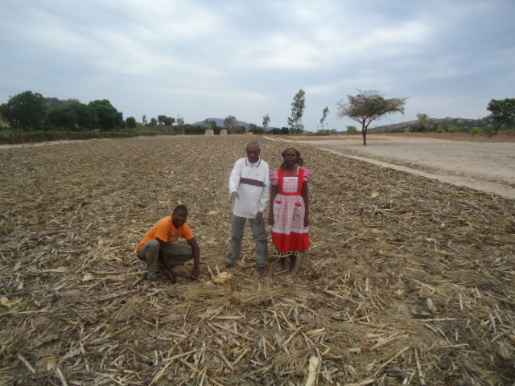
Fig 1: Mulching material Fig 2: Permanent soil cover

Principle of Mixing and Rotating Crops

• Replenishes soil fertility: intercropping with nitrogen fixing legumes adds ‘top-dressing fertilizer’ to the soil;
• Enables crops to use the nutrients in the soil more effectively:
• Helps to control weeds, diseases and pests by breaking their life cycles through the introduction of a new crop;
• Reducing the risk of total crop failure in cases of drought and disease outbreaks
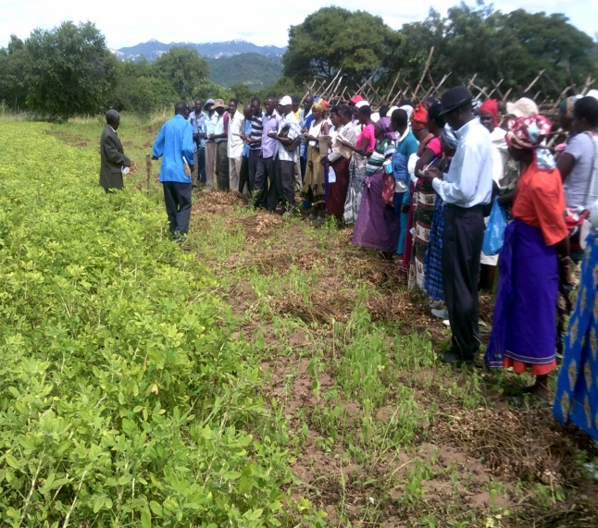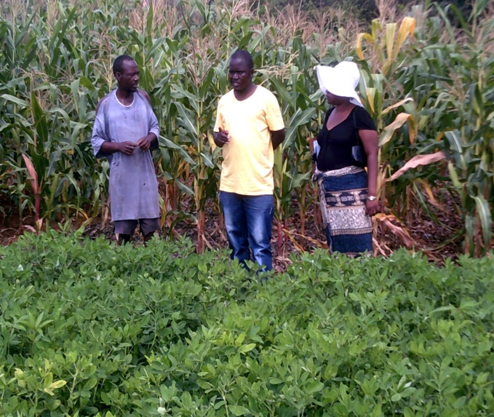
Fig 3 and 4 Crop rotation

Operational Factors

The following factors are important for the success of the Conservation Agriculture system;

Timely Operations

- A key principle of conservation agriculture is the need for timely implementation preparing the land in good time before the rains start; planting soon after an effective rainfall event;
- Weeding at appropriate times and intervals;
- Doing effective pest and disease control before either spread too widely
Precise Operations

- A major part of good management is timeliness of all operations.
- Precise measurements of row and plant spacing, evenness of depth and placement of soil amendments and covering of seed are also important.
- Planting should be done on the same lines each season.
- A key benefit is that compaction of the soil by feet, hooves and wheels will then only occur in the inter-row spaces and not over the crop lines.
- Residual fertility builds up in the rows and the crop roots of each consecutive crop provide organic matter.

Efficient Use of Inputs
- Due to this precise application of soil amendments, there is little wastage because only the crops, and not the surrounding soil and weeds, benefit.
- This gives higher yields and huge savings on costly inputs. Inputs include time, energy, draught power all of these are used more effectively under conservation agriculture.
- Timeliness of planting and weeding avoids the additional effort that will be needed if weeding is left until later in the season and the weeds get out of control.
- Since land preparation can start soon after harvesting up until the rains start, labour inputs can be spread out more evenly over the year

The disadvantages of ploughing

The primary purpose of ploughing is to turn over the upper layer of the soil, bringing fresh nutrients to the surface, while burying weeds and the remains of previous crops, allowing them to break down. It also aerates the soil, and allows it to hold moisture better. In modern use, a ploughed field is typically left to dry out, and is then harrowed before planting
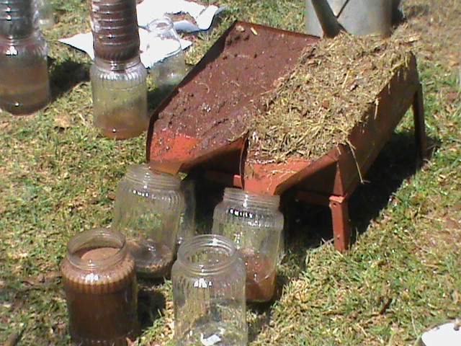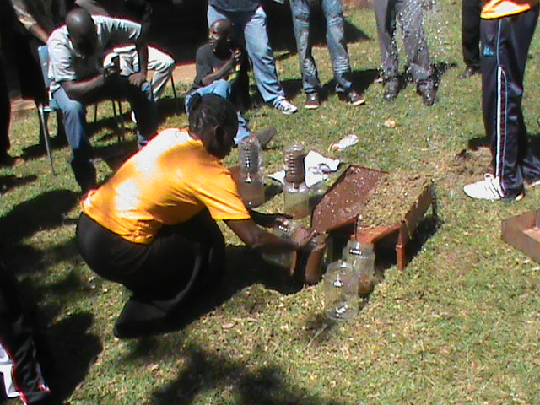Fig 5 and 6: Training demonstration on Comparison of conventional farming verses conservation agriculture

Table1: Comparison of conventional farming verses conservation agriculture
 | Conventional farming | Conservation agriculture | ...soil structure, is more labour  Intensive and...
Tillage | Farmers plough and hoe to loosen the soil and control weed | Direct planting without prior inversion of the soil; planting on the rip line or making holes for planting with a hoe | Ploughing in the long term destroys soil structure and contributes to declining fertility and organic matter levels
Crop residue | Farmers remove or burn residues or mix them into the soil with plough or hoe. | Crop residues left on the field Planting of cover crops | Crop residues improves soil structure.Cover crops protect soil from erosion and limit weed growth
Mix and rotate crops | Monocultures or crop rotation in a tillage framework where the soil is inverted with a mouldboard plough or similar implements | Crop rotation or intercropping is a permanent feature of the cropping system | Helps maintain soil fertility  Breaks disease cycles

Establishment of (CA)demonstration sites
- Three demonstration sites measuring 50 x 30m (CA)) are established in each ward.
- The demonstration sites serve as learning centers for farmers.
- The demonstration site approach reaches out to more farmers due to the strategic location of the demos within the wards.
- Different treatments such as effect of weeding, planting dates, mulching and fertility management are showcased the demonstration sites.
- Trials are conducted for different cereals and legumes including maize, sorghum, cowpeas, round nuts, groundnuts and sugar beans.
- Value addition and nutrition training is cross cutting at the demonstration sites.

Table 2: Demo layout – No lime
NO LIME
No Weeding | Weeding | Planting Date |  |  |  |  | HYBRID SC 513  100 D + 100AN |  | HYBRID SC 513  Compost + 100AN |  | OPV  100D+100AN |  | Sorghum Marcia  100D+100AN
 |  | 1st rain | 2nd rain | 3rd rain | 4th rain | 5th rain | Mulch | No Mulch | Mulch | No Mulch | Mulch | No Mulch | Mulch | No Mulch
Kgs | Kgs | Kgs | Kgs | Kgs | Kgs | Kgs | Kgs | Kgs | Kgs | Kgs | Kgs | Kgs | Kgs | Kgs

Table 3: Demo layout – with lime
LIME
Lime + 100D + 100AN |  | Lime + Compost + 100AN |  | OPV  100D+100AN |  | Sorghum Marcia  100D+100AN |  | Cowpeas MCD  100D +Lime |  | Sugar Beans  100D+Lime |  | Groundnuts Natal Common 100D + Lime |  | Fodder Beet 100D +Lime
Mulch | No Mulch | Mulch | No Mulch | Mulch | No Mulch | Mulch | No Mulch | Mulch | No Mulch | Mulch | No Mulch | Mulch | No Mulch | Mulch | No Mulch
Kgs | Kgs | Kgs | Kgs | Kgs | Kgs | Kgs | Kgs | Kgs | Kgs | Kgs | Kgs | Kgs | Kgs | Kgs | Kgs

Table 4: CA maize demo plot average results for all the districts
Treatment | Fertility management | Lower Gweru average yields | Shurugwi  average yields | Mutoko  average yields | Mudzi  average yields
Hybrid Seed, Mulch | 100kg compound D, 100kg AN | 2.31 | 2.54 | 3.07 | 2.31
Hybrid, No Mulch |  | 1.91 | 2.14 | 2.71 | 1.88
Hybrid Seed, Mulch | Compost and 100kg AN | 2.26 | 2.81 | 2.85 | 2.06
Hybrid, No Mulch |  | 1.92 | 2.24 | 2.41 | 1.80
Hybrid Seed, Mulch | Lime, 100kg D and 100kg AN | 2.79 | 2.82 | 3.20 | 2.62
Hybrid, No Mulch |  | 2.39 | 2.28 | 2.79 | 2.1
Hybrid Seed, Mulch | Lime, Compost and 100kg AN | 2.79 | 2.96 | 3.44 | 2.23
Hybrid, No Mulch |  | 2.27 | 2.23 | 2.88 | 1.8

What is compost?
- Compost is the aerobic decomposition by bacteria and fungi of a mix of organic material.
- Putrefying Organic Matter is NOT Compost.

Requirements for Making Compost
- Plant Material
- Water
- Nitrogen Source
- Oxygen
- Micro-organisms

Quantities
All the quantities suggested are in order to make 8m³ of compost.
Size of pile to get 8m³:
2.25m x 2.25m x 1.6m
Or: 2m x 2m x 2m

Plant Material
- Almost any organic material that you can find.
- Green Material (Cut Green) (40% ± 3 m³)e.g. Grass, leaves, weeds
- Dry/Woody (40% ± 3 m³)e.g. Maize Stover, sticks, seedpods, leaves, straw, wood shavings.
Timing
Late summer months when there is a lot of plant material available.

Water
- You will need about 800litres
- An open drum full of water is useful to ensure that all the material is well saturated.
- Thus dunk all the material before you add it to the pile.
- Add water as needed, when turning.(Use squeeze test).

Nitrogen Source
- Manure (from Kraal) (15% or 16 wheel barrows)
- Legume (lucerne, soya, beans) (20%)
- Urea (16kg) or Ammonium Nitrate
Remember: If you use the urea or AN, quantities of plant material need to be increased to achieve the desired 8 m³.
Oxygen
- This you don’t physically add, BUT you need to ensure that the conditions are suitable for adequate airflow.
How?
- Do NOT compact the material.
- Ensure at least 5% (½ m³) of the material is larger than 3cm in size.
- Turn the pile on time.

Building the Pile
- Peg out the area where the pile will be built
- Wet all the material thoroughly and add it to the pegged area.
- As the pile grows take special care to keep the sides and corners neat.
- Keep mixing all the materials to ensure a good blend.
- The nitrogen source must be added throughout the pile.

Turning the compost
- The temperature of compost should reach 70 °C within 2-3 days.
- Turn It!
- When turning ensure the material on the outside of the compost is placed on the inside, so that it is also heat-treated.
- The Second turn should be 4-5 days later.
- After that once a week for 3-4 turns should be enough.
- Once the temperature stabilizes below 40 °C it should be ready for use.
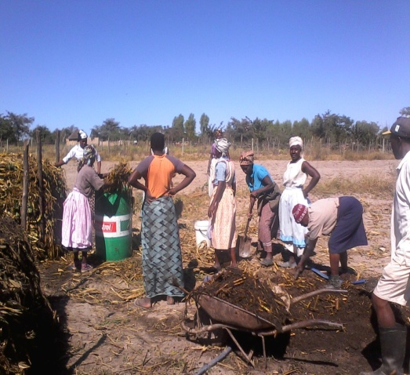
Fig 8: Training on compost making Fig 9: Training on compost making

The 5 Giants affecting crop production
- Compaction
- Pests
- Disease
- Crop Stand
- Weeds

COMPACTION

- Tradition tells us that by ploughing we are loosening the soil to prevent compaction and to get better water infiltration. But in fact the opposite is true! When rain falls on unprotected soil, the sheer weight of the water and it’s velocity on impact with soil actually COMPACTS it and it slumps.
- If you protect the soil with mulch, this cannot happen. Also, the roots from the previous crop act as scaffolding, holding the soil up preventing compaction and loosening the soil.

Pests

- Rotations are the key to slaying this Giant!
- Healthy Plants (Nutrition, water and soil) have a waxy protective leaf surface which repel pests
- Many Pests are our friends! Termites etc
- Integrated Pest Management
- There are many safe alternative treatments e.g. Stalk borer, baits

Diseases de

- Rotations are also the key to slaying this Giant!
- Once again a healthy plant can resist most diseases.
- Rotations are very important in preventing disease build up.
By ploughing you are damaging the soil structure and therefore pests and disease can build up in the soil because the soil is no longer in balance, with anaerobic and aerobic bacteria being killed

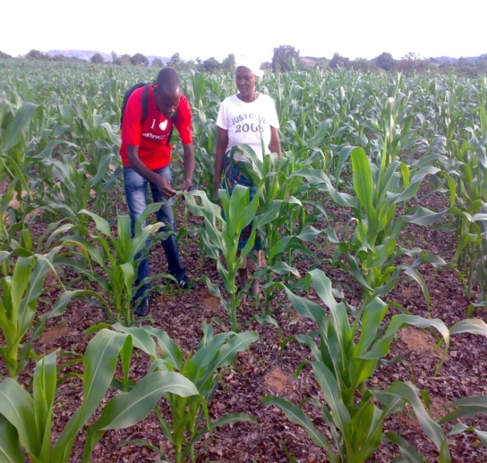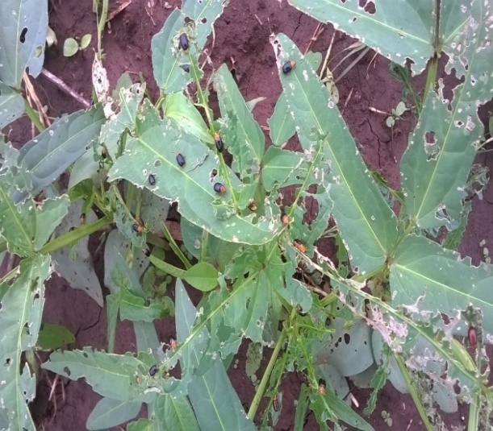
Fig 10: Identification of pests and diseases Fig 11: Pest infested cowpea crop

Crop stand

- Look to nature!
- All we need for anything to grow is “seed to soil” contact. A fine tilth is not found in nature.
- By following the FfF principles of zero tillage, no burning and leaving a good mulch cover, it is easy to get a good crop stand.
- Adhere to the management principles of being On Time, doing things to a high Standard, without Waste and with Joy.
- The soil that has been protected by mulch and is kept weed free, becomes softer and more friable after every successive year practicing FfF. It is therefore no problem attaining excellent crop stands.
- A person with a hoe is by far more accurate than a mechanical planter when sowing your seed!
Fig 12: Maize crop under conservation agriculture

Weeds

- Mulch plays a large part in controlling weed because it blocks out the sunlight preventing vigorous weed growth.
- Ploughing does not in fact help because some weed seeds can survive in the ground for up to 40 years!
Three keys to effective weed control
- Small
- Crop canopy
- Late weeding
Weed control
- 1styear – high weed pressure
- Correct plant population. - canopy
- Weed light and continuously
- 2 hours early in morning
- Cut weed just below surface
- Perennial weeds – dig and remove
- CONTROL late weeds – no canopy

Land Preparation

- No ploughing
- No burning
- Stump and clear
- Keep weed free
- Establish baseline
- Add blanket

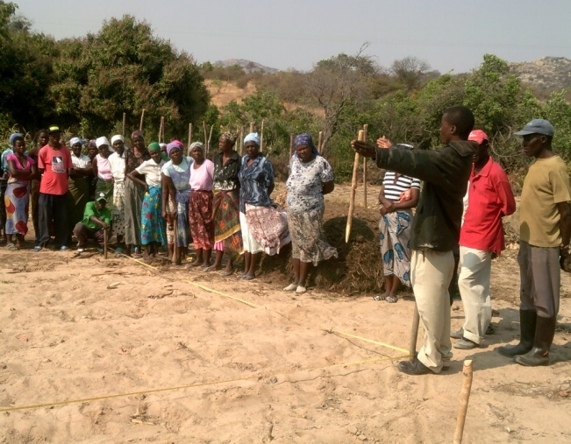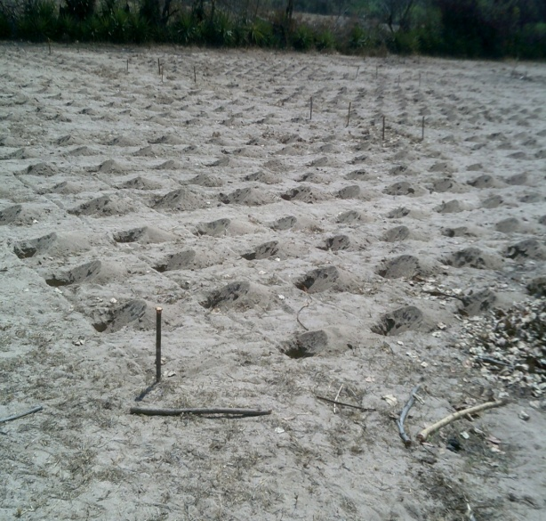
Fig 13: Land preparation Fig 14: Basin making

Basal Dressing

- Apply amount to match target yield
- Can be Fertiliser or Compost or Manure
- Place in p/station and cover leaving 5 cm for seed
- Apply before first rain – 15 November
- Row space = 75cm
- P/Stations = 60cm
- Stations/ha = 22 000
- 5cup = 130kg/ha
- 8cup = 210kg/ha
- 12cup = 316kg/ha
- 16cup = 420kg/ha
Fig15: Liming
- Apply with or before compound fertilisers are applied.

Planting

- Keep field weed free
- Following good rain after 15 Nov
- Plant within 2 days of rain
- Place 3 seeds in planting station
- Maize seed 5 cm –m/box length
- Cover carefully – no clods
- Thin to 2 plants per p/ station
- Plant population 44000/ha

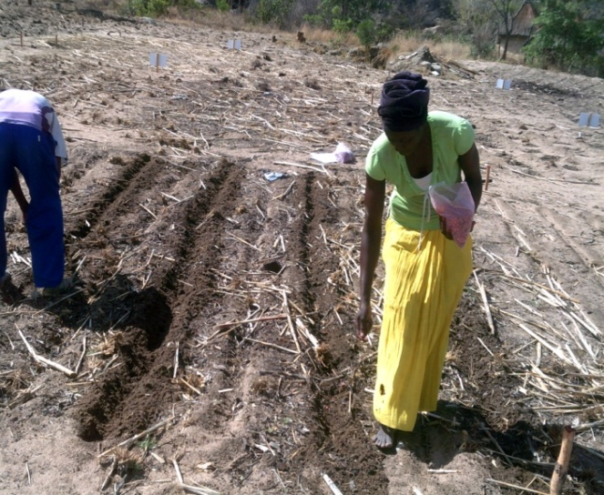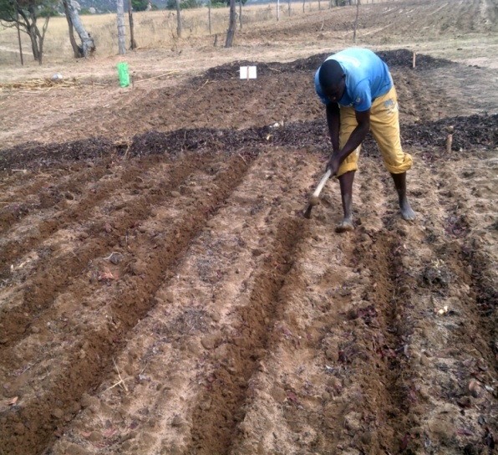
Fig 16 and 17: Planting of demos
Mulch management
- Ensure availability of adequate mulching material before the planting season.
- Mulch suppresses the emergence of winter weeds.
- Maize stover left after harvesting can be used for mulching.
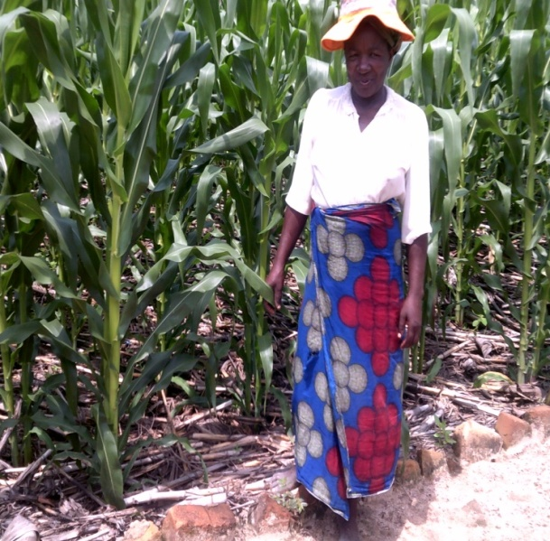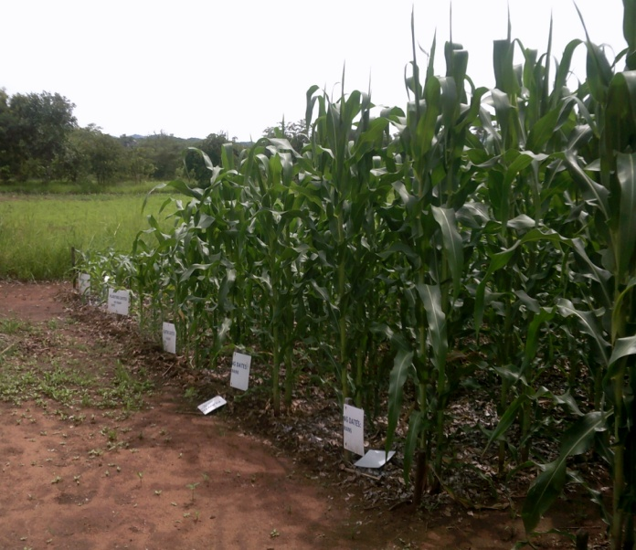
Fig 18 and 19: Mulched crop

TOP DRESSING

- Amount to match yield
- Lighter soil types – 2 applications
- Number 5 cup Urea – 3 weeks after germ
- Number 5 cup Urea –6 weeks after germ
- Urea must be covered
- In hole, foot width from plants

Fig 20: Training on application of top dressing
Basic Agronomy
- All crops withdraw nutrients from the soil.
- Nitrogen – Vegetative growth
- Phosphate – Cell division
- Potash – Growth producing nutrient.
- Micro nutrients such as Calcuim, Boron, Mg, Mn.

Nitrogen in Manure
Animal Type Kgs /Ton
Dairy 4-5
Beef 4-6
Swine 5-8
Sheep 8-12
Goat 8-12
Poultry 9-18
Horse 5-7

Chicken Manure Soup

Deficiency Symptoms - N
- Poor spindly growth
- Yellowing leaves
- Premature ripening
Excessive N – Too Vegetative, Large Soft Stems, Susceptible to Disease.

Phosphorous (P)

- Photosynthesis, Respiration
- Seed & fruit
- Energy system, growth.
- Immobile- Root zone.
- Labile (available)
- Sources – Rock phosphate, Super phosphate. Compound Fertilizers.
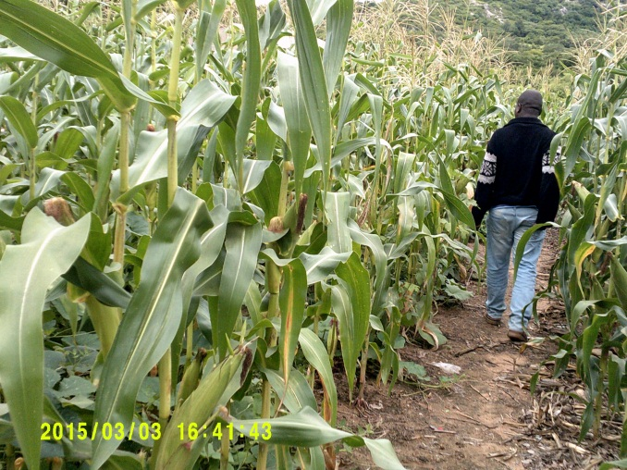
Fig 21: Crop showing adequate nutrients

Deficiency Symptoms – Phosphorus(P)
- Stunted growth
- Dull-green or blue-green color
- Possible purple coloration on some part of the plant
- Reduced flowering and/or seed production
- Delayed maturity

Deficiency symptoms - Potassium (K)
- Photosynthesis and plant food formation.
- NB with Ca and B, in development of cell walls.
- Controls the leaf stoma and affects drought tolerance.
- Solanaceous crops and Legumes.
- Improves a plants ability to combat disease.
- Affects various quality factors (colour and taste)
- Comfrey Tea

Deficiency Symptoms – Pottassium (K)
- Chlorosis of the older plant leaves.
- Wilts sooner in a dry spell.
- More severe disease problems.
- Fruit poor of quality or flavour.

BENEFITS TO SOIL/ CROP
- Drought tolerant
- Low rainfall- between 300-700mm
- Access use of hygroscopic moisture
- Strong foliage- resist dry spell = less water loss
- Waxy coating= less transpiration
- Long roots- up to 2,5m > maize- that grows larger in quantity creating a larger absorption area

Benefits to Human- Grains- nutritional values
Mealie-meal- sadza, porridge, maheu, bread, beer
- High fibre and Calcium- bones, teeth, nails
- Grain protein and amino acids composition (in sorghum vary from place grown)
- Vitamin B complex- riboflavin(energy production)
- Iron
- Protein-5.8%
- Carbohydrates-81.3-89.4%
- Fats- 1.3-2.7%
- Total ash- 2.1-3.7%

Benefits to Human- Grains- Medicinal Values
- Reduces risks of heart diseases
- Stroke
- Digestive system cancer
- Hormone related cancers
- Diabetes
- Obesity

Legumes
Benefits to soil/ crop
- Nitrogen fixation- retention of nutrients
- Decayed mulch to form humus
- Continuation of bio activity-retention of nutrients
- Controls pests and diseases
- Smothering and controls weeds e.g. witch weeds
- Less Labour to the farmer

Nutritional Values
- Carbohydrates -Bread cakes
- Fats- cooking oil
- Peanut butter
- Proteins
- Milk

HARVESTING
ing
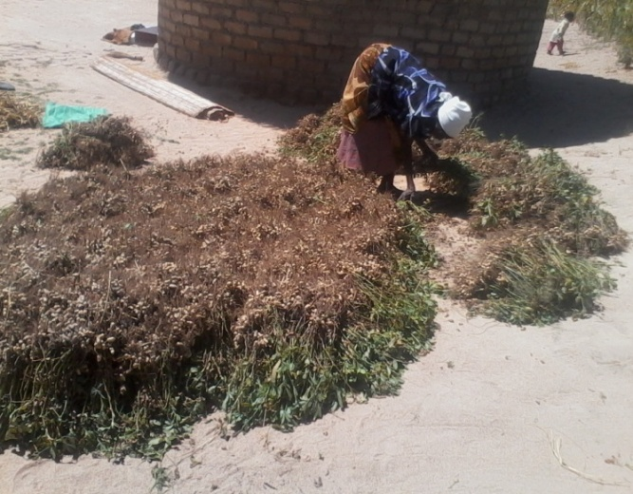
Fig 22: Harvesting maize Fig 23: Harvested groundnuts drying up
- Push stalks down between rows
- (Post Harvest Stalk Lodging)
- Break cycle of stalk borer
Fig 24: Harvested Maize

